Game Design Document
Fill up the Following document

- Write the title of your project.
=> Save Time For Family

- What is the goal of the game?

=> Importance of family member

- Write a brief story of your game?

=> A boy has to save time for his family members and take them to their respective place. There are four members father, mother, grandfather and grandmother. The boy need to take his mother to market, his father to office, his grandfather to park and his grandmother to hospital. He has to do all this in a given time. If he takes right person to it's right place then he will get 5 points but if he takes wrong person to wrong place then he will get -5 points.

- Which are the playing characters of this game?
- Playing characters are the ones which respond to the user based on the input from the user
- Cars, monkeys, dinos, wizards etc, are the playing characters in the game.
Number | Character Name | What can this character do?
1 | Boy | It's main character of the game. It is the only playing character.
2 | Father | It moves only when the boy moves it.
3 | Mother | It moves only when the boy moves it.
4 | Grandfather | It moves only when the boy moves it.
5 | Grandmother | It moves only when the boy moves it.

- Which are the Non Playing Characters of this game?
- Non Playing characters are the ones which don't have an action or a behaviour when the user interacts with the game.
- Hurdles, stones, bananas, coins, etc are non playing characters in the game.
Number | Character Name | What can this character do?
1 | ----

Draw your imagination of this game. What does this game look like?
- Draw the game either on your computer or on paper,
- Add images of scenes of the game to show each of the playing and non-playing characters at least once.
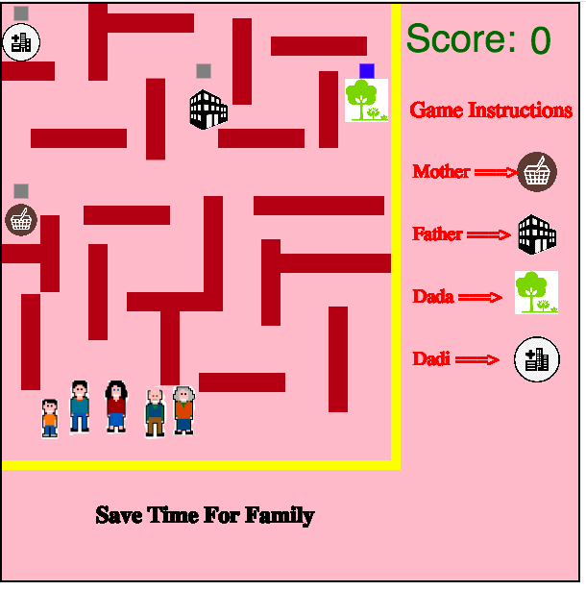
How do you plan to make your game engaging?

=> I will make the player as faster as much as the points earned.

